RESUME

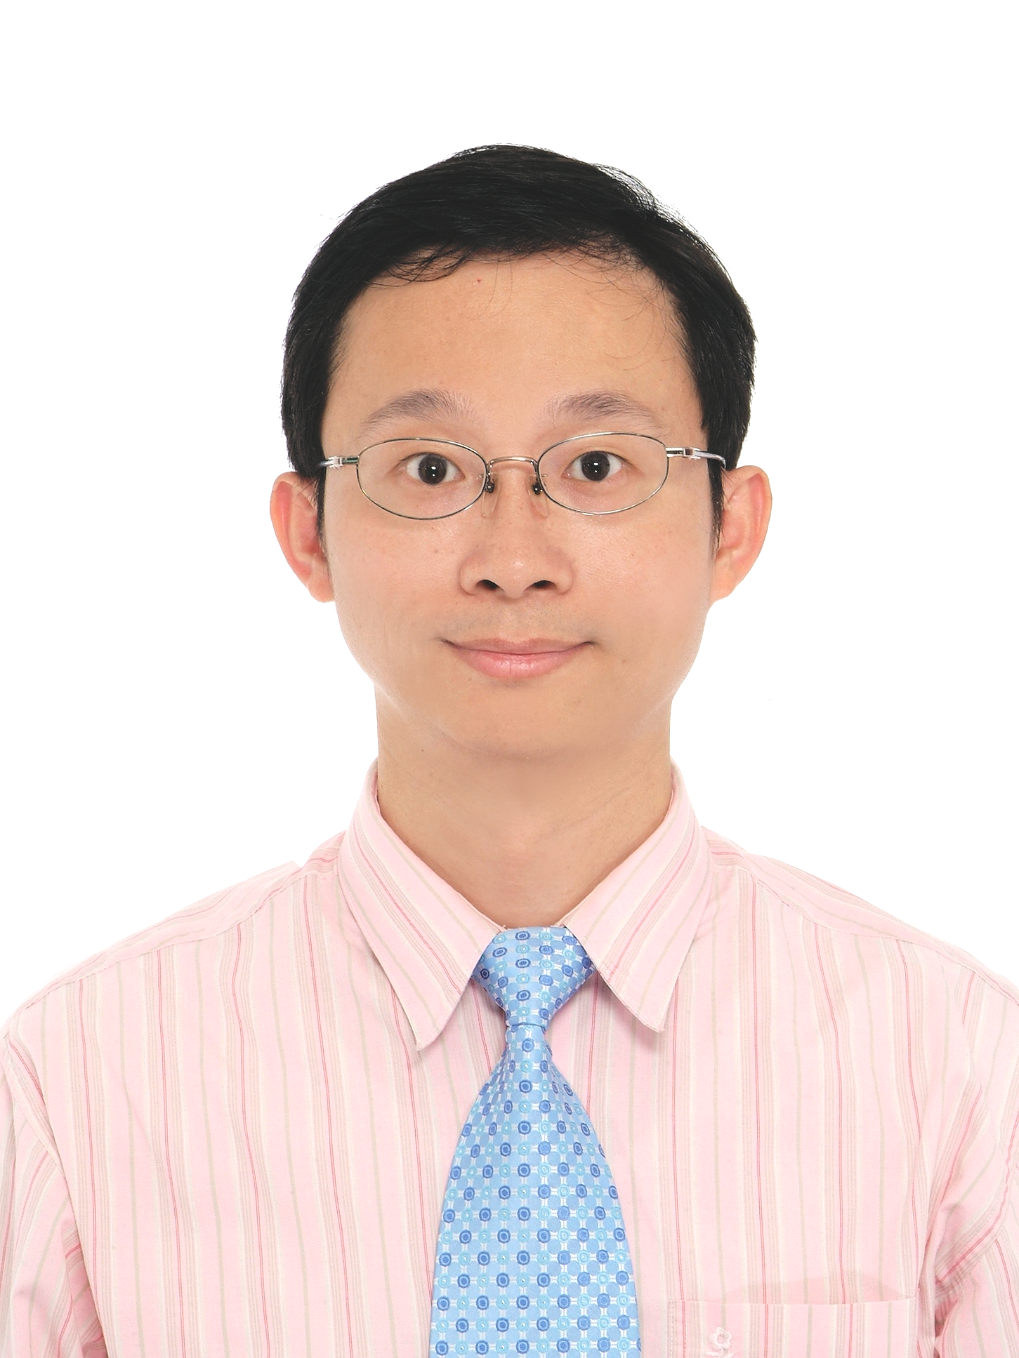
I. PERSIONAL
Name : Jyh-Yeong Tsay ( 蔡志勇 )
Birthday : 6/16/1965

Address : No 20, Lane 508 , Niu – Pu East Road , Hsin-Chu City ,Taiwan
Mobil Phone:+886-988250286 ( Please contact directly or leave the message to me)
My E-mail: jeyon@ms63.hinet.net
II. Brief Experience
- Lam Research Corp. Business Development Manager 9.15.2004~Now – 7 years
Successful on contract renewal at different account for spare and service business
Review and lead account to achieve and penetrate on MS with reasonable GM%
Lead the group meets corp. target and help group to achieve MBO goal
Review the P&L report and identify the risk area for improving
Address and communicate the issue with Headquarter till problem had been solved
Position spare market price to defense 2nd source competition
Study New Clean product in Villach for new business penetration of CY11

- Scientch Taiwan Corp is Canon Semiconductor Taiwan representative for longer time. – 4 Years
a. Scientech Taiwan Corp. Plant Manager 10.1.2003 ~ 9.14.2004
To design the tools for Lab and improve the efficiency
To handle the cleaning business
To research the chemical reaction of parts cleaning
To establish the ISO procedure and get the certification of TUV within half year: ISO 9001
b. Scientech Taiwan Corp., Sales Manager 6.1.2001 ~ 9.30.2003
SEMITOOL product sales activity, mainly focus on Etching/Cleaning/Polymer removal/Plating/ECD etc
Consultant on litho area and activity to help the sales
To survey the new business and partner as part of my jobs
To help process engineer to do the DOE and trouble shouting
Select the new chemistry to fit with tool promotion.
c. Canon Semiconductor Taiwan, Sales Manager 2.21.2000~3.31.2001
Good sales support on ProMOS / Winbond / TSMCfab6 / PSC / UMC / VIS / 12” technology consultant and so on.
Good sales on GaAs field and others– WIN / SCSC / GCT / NDL,etc.
Good communicate with customers.
- VIS is a spin-off of the Sub-Micron Project, sponsored by the Industrial Technology Research Institute (ITRI). – 10 Years
a. Vanguard, Photo lithography Equipment Manager 12.23.1994~2.18.2000
Expert on management litho equipments (Stepper/Tracker/Measurement tools)
Well manage intelligent engineer to have good discipline on PM and process control
Problem solving on litho process and tool continue improvement.
ISO certificated association.
Good skill on SPC control and TQM activity.
b. ITRI/ERSO, Photo lithography Engineer 7.9.1990 ~ 12.22.1994
Expert on Canon Stepper System, ASML, SVG and TEL track system
High skill on litho-tools maintenance and process improvements

III . EDUCATION
Jul. 2001 National Tsing Hua University Master- Industry engineering and Engineering Management, Technical management program
Jul. 1988 FEN-CHIA UNIVERSITY Bachelor -Automatic Control Engineering
IV . SKILL
July. 1990 When I was at ERSO/ITRI ,Learning course as following:
Electric-mechanism Integrate Introduction
Electric (1) (2) (3)
Semiconductor Process Introduction
C Language
ITRI 21th Quality Enhancement Camp
Organic And Solvent Management and Safety Education
Dec.1994 When I was transferred to Vanguarg, my learning course:
Financial Course for non-Financial Executives
VLSI Process Technics
Internal Quality Audit Course
NTHU Quality Engineering / Quality Management
NCTU Statistic (1)(2)/Industry Engineering and Management
NTHU Master- Industry engineering and Engineering Management, Technical management program
I had educated from Japan/American Training Course as following period:
1991.Aug SVG 90 system training and source inspection
1992.Feb TEL V Training and source inspection
1993.Feb TEL M7/M8 system training and process training
1994.Jul Evaluate Instrument from Japan and American
1996. ASML Local Basic Training Course
2002.Aug Large Account Management
2002.Aug Strategic Selling
2009.Jul 2D/3D Auto CAD Engineering Drawing Skill
2009. Sep 3D MAX Drawing Skill
2010. Mar “Photovoltaic Power Generation System” Design and Installation Certified
2010. Oct Basic Clean Product Training Course
2010. Dec Business develop strategy alignment in Villach

Awards
No.1 graduated from “420Hours Computer Digital 3D Drawing Engineer Training Class, from 07/15/2009 to 10/6/2009”
Patent
6,148,838 AUTOMATED PROCESSING LIQUID DRAIN SYSTEM (VIS Corp.)
V. Introduction
I am familiar with semiconductor field. My experts are in lithography technology and capable to be the manager of equipments. I also have good experience on strategy selling, TQM and finance budget control which I learned it from difference job functions. I am working at Lam research for business development manager around 5 years to build the new contract business model and help company accurate the finance forecast model. This is much helpful for the business management and I do believe it is very helpful on my future career.

I would like to make the brief introduction of myself to let you understand what I am doing for my passing 20 years.

My first job in ITRI, the research center of Taiwan, is very successful on the engineering site. I handle the Lithography equipments like CANON, TEL, Ultra-Tech, Track, Kla, Micro scope and so on. I got an excellent performance on it and wrote down standard operation procedure (SOP). It is good for government and new engineer. The sub-micron project turned to be the spin-off business model. Therefore, we all transfer to the company of Vangard. I am the equipment manager at that time. I need to taking care all tools available and regular maintenance. The cost down and total quality control is very important for me and I have to survey the localization to build up internal pricing and help to approval the second source parts available. During the 2000 business down size impact, I have to minimize the turn over rate and still help company growth positively. I also need to help company to pass through ISO9000 audit and new technology transfer from Misubish. (0.18um)
This period: I retain the most important engineers and coach a lot of engineers in semiconductor.

My second job experience is to be the sales manager and plant manager. I am so lucky to have chance to study master degree at NTHU, it bring my mindset to look forward career path and understand what I can do for the next step. I take the challenge to be the sales of CANON because I am familiar with that system since I am the engineering period. I use my learning of value creating and developing course/ Organized Management/ Experiment Design/ The shop flow management/ Sales Management/ Strategy Management/ Research Method/ Property and Technical Policy to successful sell tools into GaAs field and growth CANON business at 300mm semiconductor. We broke the selling record at that moment in GaAS field also. There is an opportunity when my boss transfers back to Scientch Corp, he invited me to help Scientech Company business and be the clean product sales manager. I join the sales team of Scientech Corp and help on the SEMITOOL business. It is mainly at wet cleaning and plating technology. I learn a lot of chemistries and study more communication with vendor and share my knowledge and get more feedback from customers. It made me growth up again faster. Due to the new business requirement of Scientech Corp., it did need the person who can help and handle the factory. Therefore, Scientech Corp. open the opportunity for me to consider staying in sales team or taking care all of the business of parts cleaning because I am the only one who they could trust and have factory running experience. Scientech promoted me to be the plant manager and handle both businesses and research of chemistry to have the best process solution and saving of operation. This is a very good experience of my life.
This period: I successful growth up MS from 20% to50% and triple business size.

My third job experience is to be the strongly market manager. There is another opportunity happen when my teacher introduced my resume to Lam research corp. Lam try to find the experience/capable one for business development and help on the service contract business after warranty. My teacher recommends that I should take this opportunity to build my experience on customer survey and business strategy and finance management. So I move to Lam and learn more about the customer needs and tactics and co-work through PSDM ( problem-solving decision making ). I also study and analysis the cost structure to lead our team out of risk and gain more benefits. In this period, I catch up the more management skills/market analysis to dress the way to success. After I am so successful on service contract to make the business growth up 10 times within 3 years, my boss encourage me to handle the more challenge business of Spare and defense on PRICE WAR. My biggest successful experience is to gain customer trust and willing to sign the contract with my company on spare or service portion. My proposal also help customer to understand what is the really need and benefit from our package support. It did help customer on the saving and our product position and market share protection.
This period: I successful penetrate service contract in all memory accounts and Foundry fabs to sign the Market Base Agreement. I keep MS>90% and block 2nd source competition.

Now, I am trying to look for the job to be the high level manager and demonstrate what I learn to be a global manager with the strategy on business growth up and contribute my most efforts to lead my teams to achieve the target and build the successful experience.

